Request for Proposals

for

New Renewable Capacity and Energy

(“2015 Renewable RFP”)

Issued by

PSEG Long Island



Issued December 22, 2015

Addendum 5: May 17, 2016

Proposals Due June 22, 2016

TABLE OF CONTENTS

Page No.

1.0 Introduction 4

1.1 Company Overview 4

1.2 Description of Solicitation 4

2.0 General Terms 6

2.1 Product Definition 6

2.2 Contracting 8

3.0 Communications 9

3.1 Communications during RFP Process 9

3.2 RFP Website 9

3.3 Questions about the RFP 10

4.0 RFP Schedule 11

5.0 Proposal Process 12

5.1 General 12

5.2 Interpretation or Correction of RFP Documents 12

5.3 Pre-Bid Conference Webinar 12

5.4 Notice of Intent to Propose 12

5.5 Proposal Expenses 12

5.6 Proposal Submittal Fee 12

5.7 Proposal Submittal Requirements 13

6.0 Proposal Organization 15

6.1 General Requirements 15

6.3 Cover Letter 16

6.4 Table of Contents 17

6.5 Disclosures 17

6.6 Company Data and Relevant Experience 17

6.7 Project Description 18

6.8 Technical Response 19

6.9 Project Execution Plan 21

6.10 Financial Plan 21

6.11 Pricing 22

6.12 Schedule 23

6.13 Power Purchase Agreement 24

6.14 Conditions Precedent for PPA 24

6.15 Technical Requirements, Siting and Guidance 25

6.16 Confidentiality 25

7.0 Proposal Evaluation And Selection 26

7.1 Evaluation Process 26

7.2 Evaluation Criteria 27

7.3 Notice of Award 28

7.4 Contract Approval 28

7.5 Debriefing of Unsuccessful Respondents 29

8.0 Reservation of Rights 30

8.1 General 30

8.2 Right to Reject 30

8.3 Limitations on Changes 30

9.0 MWBE Participation/ Equal Employment Opportunity 31

9.1 NYS MWBE Participation/Equal Employment Opportunity 31

9.2 NYS Service-Disabled Veteran-Owned Businesses 32

APPENDIX A 33

1.0 sCOPE 35

2.0 Reactive Power Capability and control 35

2.1 Reactive Power Capability in Normal Operation 35

2.2 Reactive Power Capability during Undervoltage Conditions 36

2.3 Reactive Power Control Capability 36

3.0 voltage and Frequency Disturbance Performance 38

3.1 Low-Voltage Ride Through 38

3.2 High-Voltage Ride Through 40

3.3 Voltage Disturbances within the Normal Magnitude Range 40

3.4 Frequency Response and Ride Through 41

4.0 Harmonic and interference Performance 42

4.1 Harmonic Current Limits 42

4.2 Harmonic Voltage Limits 42

4.3 Power Line Carrier Interference 43

4.4 Radio Frequency Interference 43

5.0 Control Performance 43

5.1 Stability 43

5.2 Control Interactions 43

6.0 transient and Temporary Overvoltages 44

7.0 Short-Circuit Contributions 45

8.0 Required Dynamic Models 45

8.1 Positive-Sequence Fundamental-Frequency Model 45

8.2 Electromagnetic Transient Model 46

Appendix B: renewable resource Injection Capability at LIPA Substations 47

# Introduction

## Company Overview

The Long Island Lighting Company d/b/a LIPA (“LIPA” or “Company”), a corporation organized and existing under the laws of the State of New York and a wholly owned subsidiary of the Long Island Power Authority, is a corporate municipal instrumentality and political subdivision of the State of New York. LIPA, by and through its agent, Long Island Electric Utility Servco LLC (“Servco”), a subsidiary of PSEG Long Island LLC (“PSEG Long Island”), provides electric service to approximately 1.1 million customers in its service area, which includes Nassau County, Suffolk County, and the portion of Queens County known as the Rockaways, in the State of New York.

To meet its customers’ electricity requirements, LIPA has secured power supply resources, consisting primarily of various power purchase contracts with third-party generation and transmission developers, and has undertaken a variety of demand-side initiatives to reduce system peak demand (i.e., offered incentive programs to customers to encourage them to adopt energy efficiency measures, install wind and solar electricity-generating systems, and participate in Load Reduction events).

Pursuant to the Amended and Restated Operation Services Agreement (“A&R OSA”) dated December 31st, 2013, as it may be restated, amended, modified, or supplemented from time to time, between LIPA and PSEG Long Island, PSEG Long Island through its operating subsidiary, Servco, assumed the responsibility as LIPA’s service provider, to operate and manage the transmission and distribution system (“T&D System”) and other utility business functions as of January 1st, 2014. On January 1st, 2015, PSEG Long Island assumed responsibility for power supply planning, and its affiliates provide certain services, such as purchasing power and fuel procurement related to these responsibilities. Additional information about LIPA and PSEG Long Island can be found on their respective websites - [www.lipower.org](http://www.lipower.org) and [www.psegliny.com](http://www.psegliny.com).

PSEG Long Island and Servco (collectively referred to as “PSEG Long Island”), as agent of and acting on behalf of LIPA per the A&R OSA, will administer this RFP. Any contract for Power Production resources must be approved by the LIPA Trustees (“Trustees” or “Board of Trustees”).

## Description of Solicitation

By resolution dated October 25, 2012, the Trustees set forth the strategy for power supply, which, among other things, created a pathway to further diversify the resource portfolio available for its customers through: continued efforts to enhance existing renewable energy programs; conducting future renewable energy procurements; replacing inefficient peaking units; and other actions and investments that might be necessary and/or feasible to reliably and economically meet future load. In particular, the Trustees set forth its plan to, among other things, seek to add 400 MW of new renewable energy generation to its resource portfolio by 2018 through an expanded feed-in-tariff program and a competitive procurement. In 2013 and 2014, this plan was implemented through the issuance of the Clean Solar Initiative II, the Clean Renewable Energy Initiative and the 280 MW RFP. These procurements fell short of the 400 MW goal. It is anticipated that approximately 210 MW additional renewable capacity will be required to meet the goal. More than 210 MW may be required if some of the selected projects[1] from the 2013-2014 initiatives fail to come to fruition.

### This 2015 RFP for New, Renewable Capacity and Energy (“2015 Renewable RFP”) is being issued to help fill this gap by procuring all of the associated energy, capacity, and environmental attributes of eligible projects 1 MW or greater. Renewable resources from the South Fork RFP, and the soon-to-be issued Western Nassau RFP, Fuel Cell Feed-In Tariff, and Commercial Solar Feed-In Tariff will also help meet this gap. Responses to the 2015 Renewable RFP, Fuel Cell Feed-In Tariff, and Commercial Solar Feed-In Tariff are anticipated to be evaluated concurrently.

### Amounts of renewable capacity in excess of 210 MWs may be selected to manage the risk that some selected projects do not advance to commercial operation, as well as to capture potential economic benefits for customers. The 2015 Renewable RFP does not contain a maximum size limit on an individual project. Respondents should note, though, that while all projects will be evaluated to determine which project(s) provide the greatest net benefits to LIPA customers, projects whose size is in excess of the targeted amount may be disadvantaged economically.

# General Terms

## Product Definition

### Technologies being proposed must produce electric power for injection into the Long Island electric system from new “renewable” energy sources. Moreover, the proposed technology must be considered both proven and commercially available at the time of submittal. Applicable renewable energy resources include:

### Solar, on and offshore wind, hydropower, tidal, and geothermal resources;

### Fuel cells that use 100% renewable energy sources and offer a fixed price (All other fuel cells should apply to the Fuel Cell Feed-in Tariff);

### Direct-fired generators using a biomass fuel such as agriculture or animal waste, small diameter timber, salt cedar and other phreatophyte or woody vegetation obtained within New York, biogas (landfill gas to electricity), and anaerobic digestion to electricity; and

### Storage systems paired with the above renewable technologies provided that the associated energy is delivered to the same interconnection point.

### For the purpose of clarity, all MW values discussed in this RFP are determined at the revenue meter.

### The minimum renewable generating capacity for each project or single point of interconnection is 1 MW[2] nameplate capacity (AC).

### Projects must be newly constructed with a Commercial Operation Date (COD) on or after the date of contract execution.

### Projects intending to connect to the distribution system (Point of Interconnection on 13 kV or lower) must follow and adhere to the interconnection procedures associated with the applicable Project capacity:

#### Resources must be connected directly to the distribution system in accordance with LIPA’s Smart Grid Small Generator Interconnection Procedures (“SGIP”). For further information on interconnection requirements, Respondents should contact Steve Cantore of the Power Asset Management Department, Phone (516) 949-8295, E-mail: [Stephen.Cantore@PSEG.COM](mailto:Stephen.Cantore@PSEG.COM).

#### A Project that connects directly to a distribution circuit outside of the substation is limited to a maximum of 3 MWs. The exact power injection will be determined on a case by case basis by the Power Asset Management Department.

#### A Respondent that proposes a renewable facility connected via a dedicated distribution feeder is limited to a maximum of 10 MW. If a proposal is greater than 10 MW, it must connect to the transmission system. (Point of interconnection on 23 kV system or higher) and adhere to those procedures set forth in Section 2.1.7 where applicable.

* + 1. All Projects must include Direct Transfer Trip and Supervisory Control and Data Acquisition (SCADA) in its design.

### All Projects intending to connect to the transmission system (Point of Interconnection on 23 kV or higher) must adhere to the NYISO’s Large Generator Interconnection Procedures, NYISO’s Small Generator Interconnection Procedures, and LIPA’s Small Generator Interconnection Procedures, as applicable. Respondents are encouraged to seek information about potential interconnection points in accordance with LIPA’s interconnection procedures, which are available on [the RFP website](http://www.pseglirenrfp.com/Index.html). For further information on interconnection requirements, Respondents should contact Steve Cantore of the Power Asset Management Department, Phone (516) 949-8295, E-mail: [Stephen.Cantore@PSEG.COM](mailto:Stephen.Cantore@PSEG.COM).

### Proposed Projects are encouraged to produce power as soon as practical after contract execution, but must be commercially operable and providing renewable energy and related capacity to Long Island electric system[3] on or before May 1, 2022. See schedule in Section 4.0 for further details.

### Projects must electrically connect to the Long Island electric system or provide a new transmission line onto Long Island that will electrically connect to the Long Island electric system.

### Each Project owner will be responsible for the costs of transmission and distribution upgrades to the Long Island electric system associated with its Project.

### There are four conditions for off-island projects:

### The project must be newly constructed with a COD on or after the date of contract execution;

### The project must secure firm delivery over a new transmission line to the Long Island electric system. This line must begin commercial operation after the date of contract execution and before Project COD and must have transmission capacity equal to the Project’s AC MW rating dedicated to the Project. Use of existing transmission lines is not allowed;

### The Project must secure firm transmission from the renewable resource to the injection point on the transmission line; and

### Current and future costs associated with firm transmission and transmission upgrades for all systems other than the Long Island electric system will be borne by the Respondent and must be included in firm project pricing.

### All Project facilities and interconnection facilities must be designed to withstand 130 mph winds and have equipment elevations to accommodate updated one-in-500 year flood zones.

## Contracting

### The selected Respondent(s) will be required to execute a long term power purchase agreement (“PPA”) with LIPA. Respondents may propose a term between 10 and 30 years in 5-year increments. A standard form PPA with options for different resource types will be available on [the RFP website](http://www.pseglirenrfp.com/Index.html). Each Proposal shall provide a “red-line” mark-up to the standard form PPA with any comments, insertions, deletions, or other proposed changes, which must include proposed text, as applicable.

#### Redlines shall only be provided using “Track Changes” in Microsoft Word.

#### Respondent modifications that are not clearly identified using “Track Changes” will not be negotiated in the contract.

#### Proposals will only be accepted that offer a bundled product of electric energy, environmental attributes (RECs), and capacity.

# Communications

## Communications during RFP Process

### Pursuant to State Finance Law Sections 139‐j and 139‐k, a Respondent is restricted from making contact or communicating with any LIPA or PSEG Long Island representative, other than as designated herein, from date of issuance of the RFP through the final award and approval of the resulting Procurement Contract (as that term is defined under State Finance Law). Violation of this provision may subject the Respondent to immediate disqualification from the RFP process.

### Respondents are to direct any and all communication regarding this RFP to only the listed designated/identified contacts or through [the RFP website](http://www.pseglirenrfp.com/Index.html).

### Designated Contacts for this RFP include:

* + - 1. Edmund Petrocelli, Manager of Power Projects – General RFP related inquiries, (516) 222-3643 , Edmund.Petrocelli@PSEG.COM

### Steve Cantore, Manager of Power Asset Management Department – Interconnection related inquiries, (516) 949-8295, Stephen.Cantore@PSEG.COM

### Robert Binder, Staff Engineer, Planning and Evaluation – Renewables related inquiries, 631-844-3839, Robert.Binder@PSEG.COM

### Designated contacts will be updated and/or supplemented as needed and all such changes will be posted on [the RFP website](http://www.pseglirenrfp.com/Index.html).

### Respondents are to direct any and all questions regarding this RFP to only the listed designated/identified contacts (listed above) or through the RFP website at [www.pseglirenrfp.com/QandA.html](http://www.pseglirenrfp.com/QandA.html).

### Further information about these requirements can be found in the Lobbying Guidelines Regarding Procurements, Rules, Regulations, or Ratemaking, which is posted on [the RFP website](http://www.pseglirenrfp.com/Index.html).

## RFP Website

### For further information, please refer to the 2015 Renewable RFP website that is accessible at [www.pseglirenrfp.com](http://www.pseglirenrfp.com/Index.html) and through PSEG Long Island’s website (www.psegliny.com) in the “About Us” folder under “Proposals”. The RFP website is a public site, accessible to anyone at any time. The RFP website allows Respondents to download documents referenced in the RFP. Interested entities may register for website updates on the RFP website or by emailing [register@pseglirenrfp.com](mailto:register@pseglirenrfp.com). Registrants will be invited to login to the Private RFP Site (<https://pseglirenrfp.sharefile.com/login.aspx>) administered through Citrix ShareFile. The RFP website contains a link to the Private RFP Site.

### Respondents may request certain transmission system data to assist them in developing their proposals. PSEG Long Island will provide interested Respondents a load flow, contingency list, and a one-line diagram around an electrical bus at a proposed interconnection point. Inquiries should be directed to Steve Cantore, Manager of Power Asset Management Department. Prior to any such discussions a non-disclosure agreement must be executed between Respondent and PSEG Long Island.

## Questions about the RFP

### All questions and clarifications unrelated to interconnection inquiries concerning these RFP Documents may be electronically submitted through the RFP website at <http://www.pseglirenrfp.com/QandA.html>. Such questions or clarifications must be submitted by the “RFP Question Submittal Deadline”, as specified in the RFP Schedule, in order to be considered.

### All questions and answers concerning this RFP will be available (on an anonymous basis) to all registered users of the RFP Website. They will be posted to the Private Site (<https://pseglirenrfp.sharefile.com/login.aspx>) administered by Citrix ShareFile in a folder called “RFP Q&A.”

### Interconnection inquiries should be directed to Steve Cantore, Manager of Power Asset Management Department. Prior to any such discussions a non-disclosure agreement must be executed between Respondent and PSEG Long Island.

# RFP Schedule

The following RFP Schedule is based upon expectations as of the release date of this RFP. PSEG Long Island reserves the right to modify the RFP Schedule at its discretion.

Table 1: RFP Schedule

|  |  |
| --- | --- |
| **ACTIVITY** | **DATE** |
| Release of RFP | December 22, 2015 |
| Registration for Pre-Bid Conference Webinar | January 15, 2016 |
| Pre-bid Conference Webinar | January 20, 2016, 3 PM EST |
| Question Submittal Deadline | May 4, 2016 |
| Notice of Intent to Bid Deadline | June 8, 2016 |
| Proposal Submittal Deadline | June 22, 2016, 3 PM EDT |
| Proposal Selection(s) (planned) | January, 2017 |
| Execution of Contract(s) (planned) | 3rd and 4th Quarter of 20171 |
| Firm Pricing Required Through | May 1, 2018 |
| Latest COD2 | May 1, 20223 |

1 If required, SEQRA must be completed prior to contract execution.

2 Staggered startup will be allowed to occur in blocks no smaller than 25% of Project size with a minimum of 1 month between block startup with total Project capacity installed within two years. Power delivery from the first block shall be no later than May 1, 2022.

3 First of the month CODs are required.

# Proposal Process

## General

### Complete sets of the RFP Documents may be obtained from [the RFP website](http://www.pseglirenrfp.com/Index.html).

### PSEG Long Island and LIPA assume no responsibility for errors or misinterpretations resulting from the use of incomplete sets of RFP Documents.

### Proposals shall include, at a minimum, each of the required elements summarized in Section 6.0 herein.

## Interpretation or Correction of RFP Documents

### Any Respondent who discovers any ambiguities, inconsistencies, omission or error or is in doubt as to the meaning or intent of any part of the RFP documents shall request an interpretation from PSEG Long Island. Such request shall be submitted via the Question and Answer process provided on [the RFP website](http://www.pseglirenrfp.com/Index.html).

### If a Respondent fails to notify PSEG Long Island of a known error or an error that reasonably should have been known prior to the final filing date for submission, Respondent shall assume the risk, and shall not be entitled to alter its proposal after the submission deadline.

### Modifications to the RFP Documents will be furnished via [the RFP website](http://www.pseglirenrfp.com/Index.html).

## Pre-Bid Conference Webinar

### A pre-bid webinar will be held on January 20, 2016. Interested participants should register via [the RFP website](http://www.pseglirenrfp.com/Index.html) by January 15, 2016.

## Notice of Intent to Propose

### Respondents are encouraged to submit a “Notice of Intent to Propose” via the RFP website at least two weeks prior to the Proposal Submittal Deadline.

## Proposal Expenses

### Respondents shall bear any and all labor, materials and content costs and expenses required for or in connection with preparation of its Proposal; subsequent actions taken by Respondent up to the execution of the PPA, including clarification of the Proposal and negotiation of the PPA; all taxes, duties, fees, and other charges that may be associated with completion of the Project; and compliance with all local, state, and federal laws and regulations that may affect the Project and the PPA.

## Proposal Submittal Fee

### Each Proposal shall be accompanied by a submittal fee in the amount of $1/kW.

#### Respondents who submit more than one proposal for the same interconnection point or Project site, must pay a separate fee for each proposal.

### Proposals shall be submitted with the applicable submittal fee in the form of a certified check or bank check made payable to PSEG Long Island. Proposals without the required fee will not be considered or evaluated. All proposals submitted in response to this RFP will be retained by the Company in order to maintain a complete record of the procurement and will be subject to the confidentiality provisions described herein Those proposals that are not selected will not be returned to the Respondent.

### The submittal fee will be returned for:

### Proposals that are not timely submitted.

### Proposals that are incomplete or non-responsive.

### Proposals that are not selected and approved by the Trustees.

### Submittal fees will be returned in a timely manner shortly after the completion of each evaluation phase described in Section 7.1.6 and no interest will be paid on refunded amounts.

### Any unrecovered proposal evaluation costs will be recovered from Respondents with executed contracts via lump sum payments at the start of each contract with payments associated with individual contracts in proportion to the MW size of the contract relative to the total MWs procured via the RFP. Each Project contract will be allowed an adder for the first five years of the contract to recover the lump sum payment. The adder will be calculated as a lump sum payment divided by the projected MWh of the unit’s output over the 5 year period. Once the projected amount of energy has been produced, payment for the adder will cease.

## Proposal Submittal Requirements

### Proposals are limited to one Project. Multiple proposals by a single Respondent are permitted but will require separately bound copies for each proposal and additional submittal fees.

### Respondents submitting multiple proposals must identify if any are mutually exclusive from other Proposal(s) from that Respondent.

### Proposals shall be submitted in the complete name of the party expecting to execute any resulting contract. The Proposal shall be executed by a person who is duly authorized to bind Respondent to a contract.

### Respondents who submitted a renewable project in the 2015 South Fork Resources RFP may submit the same proposal in this RFP, but must clearly identify on the cover page of the Proposal the name of the Respondent and name of the Proposal submitted in the 2015 South Fork Resources RFP. Similarly, a renewable project may be submitted in both this RFP and as part of a proposal in the Western Nassau RFP (to be issued subsequent to this RFP), but must clearly identify this on the cover page of both Proposals.

### All Proposals submitted in response to this RFP must be received by the Proposal Submittal Deadline. Proposals received after this deadline will be disqualified from further evaluation. All proposals submitted in response to this RFP will be retained by the Company in order to maintain a complete record of the procurement and will be subject to the confidentiality provisions described herein. .Those proposals that are not selected will not be returned to the Respondent.

### After the submittal deadline, no Material Changes may be made to the Proposal.

### Three (3) bound hard copies of each Proposal and one (1) electronic copy of each Proposal (sent via CD, DVD, or flash drive) shall be submitted to PSEG Long Island at the following address:

Ms. Gracia DeSilva

PSEG Long Island

333 Earle Ovington Blvd., Suite 403

Uniondale, New York 11553

### Hard copies of Proposals shall be bound and the cover clearly marked with:

#### Project name.

#### Project nominal capacity (MW) and technology type(s).

#### RFP title (2015 Renewable RFP).

#### Name and address of Respondent.

#### Identification as to whether this proposal is a “Mutually Exclusive Proposal” or has been submitted in the South Fork Resources RFP or is anticipated to be submitted in the Western Nassau RFP.

### Hard copies of proposals should include clearly-labeled tab dividers between each section.

### Proposals must be submitted as hard copies along with the electronic copy. Proposals sent by facsimile or email are not acceptable and will not be evaluated or considered.

# Proposal Organization

## General Requirements

### Proposals shall include each of the required elements summarized herein. This applies to each Proposal that is submitted by Respondent (i.e., each Proposal shall stand alone in satisfying these requirements).

### Proposals that do not include the required information will be deemed non-responsive, and will not be evaluated. All proposals submitted in response to this RFP will be retained by the Company in order to maintain a complete record of the procurement and will be subject to the confidentiality provisions described herein.. Those proposals that are not selected will not be returned to the Respondent. Non-responsive proposals include, but are not limited to, those that:

#### Are not in conformance with RFP requirements and instructions.

#### Are conditioned on some other act or omission (other than as required by law) whether or not related to this procurement and the resulting contract. Without limiting the generality of the foregoing, by way of example, the following are conditional proposals:

#### Proposals that request extension of an existing contract

#### Proposals that are dependent upon cancellation of another contract

#### Proposals that are dependent upon not being selected in another RFP (other than exceptions noted in Section 5.7.4)

#### Do not include the required Proposal Submittal Fee.

#### Contain any material omission(s).

#### Do not meet the submission requirements set forth herein.

### Respondent may submit complementary information not explicitly requested within the RFP Documents. Such information shall be provided in addition to, not in lieu of, the requested information.

### All documents, schedules, and other similar items submitted as a part of a Proposal are to be clearly labeled and organized in a fashion that facilitates easy location and review.

### As a corporate municipal instrumentality of the State of New York, documents in LIPA’s possession or the possession of its agent PSEG Long Island are presumptively available to the public under New York’s Freedom of Information Law (“FOIL”), Public Officers’ Law (“POL”) Article 6. Respondents are strongly encouraged to familiarize themselves with the obligations and requirements of FOIL. Consistent with Section 87(2) of the POL, Respondents shall indicate in their proposal, what information, if any, should not be made publicly available by marking such information as confidential. Information marked confidential will be treated as such to the extent consistent with obligations under the Freedom of Information Law (“FOIL”), other applicable law, regulation, or legal process, and will not be disclosed except as required by law, or as necessary for the evaluation of proposals. In the event that LIPA receives a FOIL request for any or all proposals submitted in response to this RFP, LIPA will notify the submitting entity of the FOIL request pursuant to Section 89(5) of the POL.

### Proposal Outline and Content

* + 1. Proposals submitted in response to this RFP are required to follow the outline below in terms of format. Following the outline there are sections corresponding to the outline that provide additional information and guidance regarding the outline item and required information. Note that not all requirements listed within the proposal outline sections may be applicable to all resources. Respondents should exercise their judgment when determining whether or not a requirement is applicable to their proposal and incase of doubt he/she should contact the designed contact persons for this RFP.
    2. Proposal Sections

### Cover Letter

### Table of Contents

### Disclosures

### Company Data and Relevant Experience

### Project Description

### Technical Response

### Project Execution Plan

### Financial Plan

### Pricing

### Schedule

### Power Purchase Agreement

### Conditions Precedent for PPA

### Technical Requirements, Siting and Guidance

### Confidentiality

## Cover Letter

### The cover letter shall include an “executive summary” of the highlights and special features of the Project or Proposal.

### The cover letter shall be signed by Respondent’s primary point of contact and the individual(s) that are duly authorized by the Respondent to make a binding offer.

### The cover letter shall include contact information for Respondent’s primary point of contact, including name, title, address, phone, email, and fax.

### The cover letter shall contain a statement clearly indicating the time period during which the Proposal (including pricing) will remain effective. At a minimum, the Proposal must remain effective through the “Firm Pricing Required through Date” noted in the RFP Schedule.

### The cover letter shall clearly identify if the Renewable Project proposal has been or is anticipated to be submitted for any other active RFP on the PSEG Long Island website.

## Table of Contents

### Proposals should include a table of contents that clearly lists all items submitted in response to this RFP and is consistent with the requirements for Section 6.2.2.

## Disclosures

### Respondent shall provide a disclosure of any instances in the last five years where Respondent, any of its officers, directors or partners, any of its affiliates, or its proposed guarantor (if any) defaulted or was deemed to be in noncompliance with any obligation related to the sale or purchase of power (capacity, energy and/or ancillary services), transmission, or natural gas, or was the subject of a civil proceeding for conversion, theft, fraud, business fraud, misrepresentation, false statements, unfair or deceptive business practices, anti-competitive acts or omissions, or collusive bidding or other procurement- or sale-related irregularities.

### Respondent shall provide a disclosure of any instances in the last five years where Respondent, any of its officers, directors or partners, any of its affiliates, or its proposed guarantor (if any) was convicted of (I) any felony, or (ii) any crime related to the sale or purchase of power (capacity, energy and/or ancillary services), transmission, or natural gas, conversion, theft, fraud, business fraud, misrepresentation, false statements, unfair or deceptive business practices, anti-competitive acts or omissions, or collusive bidding or other procurement- or sale-related irregularities.

### Respondent shall provide a signed and completed Contractor Disclosure of Prior Non-Responsibility Determinations, MacBride Fair Employment Principles, Contingent Fee Certification, Non-Collusive Bidding Certification and New York State Vendor Responsibility Questionnaire/Certification forms, as available on [the RFP website](http://www.pseglirenrfp.com/Index.html).

## Company Data and Relevant Experience

### Proposals must contain:

#### Company name, address and telephone number (and name, address, telephone number, and e-mail address of the contact person for Respondent in connection with its Proposal);

#### Legal status (e.g., corporation, partnership, Limited Liability Company), date formed, jurisdiction of organization, and identification of any relevant affiliates;

#### Ownership status (e.g., privately held or publically traded);

#### Guarantor information (same information as subparagraphs (1) and (2) in this section) if applicable;

#### If a consortium submits a Proposal in response to this RFP, the consortium will clearly provide information on its legal form and each of its members, and identify the member responsible for providing all financial security, executing the PPA, and providing Products to LIPA (the “Lead Member”).

#### Company history and experience in the areas of development, financing, construction, and operation of renewable generating plants (number of MW and projects by technology and location);

#### Provide organizational chart that describes the reporting relationships of all key personnel and team members/partners along with bios and team experience in developing similar projects.

#### Familiarity and experience with NYISO requirements; and

#### Existing electric generating plants owned and/or operated by Respondent.

## Project Description

### Provide a full and complete description of the proposed Project including technology, nominal capacity (both real and reactive), size (acreage), existing site conditions, adjacent land uses, nearby structures and facilities, and environmental conditions or requirements.

### Provide a full and complete description of the businesses, residences and other pertinent land uses surrounding the location of the proposed Project.

### The proposed Project shall be located on a site controlled by Respondent through either fee ownership, a land lease, option to lease or purchase, or equivalent demonstration of site control. Respondent shall provide evidence of such site control or its plan to obtain site control in its Proposal.

### Site characteristics (including identification of the zoning for the site and a description of whether the proposed Project is a permitted use under the local zoning code or has received a zoning code waiver that will allow the Project to be built and operated; a discussion of any known sensitive environmental features on or adjacent to the site such as wetlands, historic properties, ongoing hazardous materials remediation, residences or other sensitive noise receptors; and a discussion of storm resistant features and other reliability features);

### Proof of appropriate local zoning or confirmation in writing from the involved municipality that a change in zoning will occur a minimum of one month prior to the “Proposal Selection(s) (planned)” date in Table 1, or a waiver from the involved municipality, is a requirement of this RFP.

### If permits have already been obtained, Respondent shall provide copies, and if not, Respondent shall provide a plan and schedule for obtaining all required permits.

### All permits must comply with any and all State, County, Town or Local Municipality laws, ordinances, or regulations that have been established including those with respect to renewable installations.

## Technical Response

### Technology Description:

#### Provide a full and complete description of the technology being proposed. Respondent shall include a listing of all Projects in which Respondent has previously incorporated this technology, including the size (MW), location, and commercial operation date of each.

#### Provide projected equivalent availability factor for 100% renewable fueled fuel cells and biomass facilities only, or the percent of time during a specified period that the facility is capable of providing service. All assumptions (including periods of exclusion or carve-out) in deriving this availability factor should be specified.

#### Provide projected hourly power output, at 50%, 90% and 99% probabilities of exceedance (i.e., P50, P90, and P99).

#### For 100% renewable fueled fuel cells and biomass facilities, provide a summary of planned outages, or the percent of time during a year that the facility is scheduled to be out of service for routine maintenance.

#### Describe to what extent the Project can provide/absorb MVARs to control voltage. A statement committing the Project to meeting all of the technical requirements of Appendix A for transmission connected Projects or the Long Island System interconnection requirements for Projects connected at the distribution level. In the event that there are some exceptions to these requirements, each exception shall be identified and the committed performance shall be described in detail.

### One-Line Diagram:

#### Provide a comprehensive one-line diagram describing the electrical equipment and point of interconnection or deliverability to the Long Island electric system.

#### Compliance with LIPA’s SGIP, the NYISO’s LGIP requirements, and LIPA’s Long Island T&D Design Criteria is required.

#### Respondents may request certain transmission system data to assist them in developing their proposals. PSEG Long Island will provide interested Respondents a load flow, contingency list, and a one-line diagram around an electrical bus at a proposed interconnection point. Respondents should submit a request to Steve Cantore of the Power Asset Management Department, Phone (516) 949-8295 and will be required to execute a non-disclosure agreement.

### Site Layout:

#### Provide a layout of the Project site using a white background, including site boundaries, access, location of equipment and buildings, and routing of the transmission line from the Project to the point of interconnection.

#### Provide a layout of the Project using an aerial background, including site boundaries, access, location of equipment and buildings, and routing of the transmission line from the Project to the point of interconnection.

#### For solar PV projects, provide at a minimum, the following information:

#### Percent of lot to be covered by solar panels

#### Setback from property line to nearest solar panel or inverter

#### Maximum height of any structure

#### Description of natural screening designed into the Project

### Data Sheet:

#### Complete the appropriate data sheet for the technology being proposed. The data sheets are available on the RFP web site.

#### Provide Dependable Maximum Net Capability (“DMNC”) according to NYISO Standards including (i) expected seasonal peak capacity (MW) for summer and winter and (ii) expected output at ISO conditions.

#### Print the data sheet(s) and include a hard copy within the Proposal as well as submit the completed data sheet(s) electronically in Excel format.

### Annual Energy Production Forecast [4]:

#### Provide an average (P50) *hourly* net energy production forecast. This forecast shall represent the average hourly net energy delivered to LIPA at the point of interconnection. The 8760 forecast, required for only the initial full calendar year of operation, shall be submitted electronically to the Designated Contact(s) using the Excel format specified in the data sheets available on the RFP Website. Do not submit the full 8760 forecast in hard copy format.

#### Provide the expected (P50) net annual energy production for each year of the contract.

#### Provide an uncertainty forecast for the net annual energy production estimate. Proposals shall include corresponding estimates for P90, P95, and P99 net annual energy production.

#### Provide a description of the assumptions, data, and calculations used to prepare these forecasts.

#### Fuel Supply Plan (for projects that use fuel)

#### Full and complete description of fuel supply plans. It shall incorporate details regarding fuel procurement, supply, transportation and storage.

#### Respondent is responsible for supplying all fuels and shall provide a statement indicating that they will be responsible for all fuel procurement, supply, transportation and storage and that all costs associated with supply of fuel are incorporated into the fixed price bid as submitted in response to this RFP.

## Project Execution Plan

### Respondents shall provide a brief description of how they intend to complete the Project and deliver renewable energy to the Long Island electric system.

### A description of the major engineering, procurement, and construction (“EPC”) and operations and maintenance (“O&M”) contractors the Respondent intends to utilize shall be included. Describe the nature of its labor force and how they expect to complete the Project without labor delays.

### Respondents shall describe the status of development and permitting, including a detailed list of all permits received and any permits needed prior to achieving commercial operation of the Project.

### Respondents shall be required to keep PSEG Long Island informed of Project progress during development; therefore, Respondents shall provide a description of the process that would be used to update PSEG Long Island on Project progress and changes in the projected installation schedule.

### Respondents shall provide a community outreach plan, including evidence of community support, if any, for the proposed Project, which can be in the form of correspondence from local elected officials and community groups.

### The Respondent should identify any New York State or Long Island based companies that will be involved in this Project.

### The Respondent should identify any certified MBE/WBE or Service-Disable Veteran-Owned Business that will be involved in this Project. See Section 9 for additional information.

### Any Project resulting from this RFP is considered by New York State to be a Public Works Project. Therefore Prevailing Wage requirements as dictated by the New York State Department of Labor will apply. These rates are posted on the RFP web site.

## Financial Plan

### Proposals must contain evidence of Respondent's and any Guarantor's financial condition and financial capacity to complete and operate the proposed Project as evidenced by a “Financing Plan.” Proposals must provide:

### A detailed description of proposed short- and long-term financing arrangements.

### A list of all equity partners, sources of equity and debt, debt structure.

### Demonstrate that financial arrangements are sufficient to support the Project through construction and the PPA term.

### Describe proposed capital structure for the Project.

### A schedule showing all major projects financed by Respondent in the past 10 years.

### Provide details of any events of default or other credit issues associated with all major projects listed in Section 6.10.6 above.

### Identify proposed Guarantor(s) for the Project and provide documentation of the Guarantor’s creditworthiness including credit ratings, where available, and the three most recent audited financial statements of the Guarantor.

### Information concerning the Respondent’s financial condition and evidence of creditworthiness including:

### Audited financial statements for its three most recent fiscal years; or

### Audited financial statements from Respondent’s parent, if Respondent does not have such financial statements; or

### Statement describing why the statements in either 6.10.9 (1) or 6.10.9 (2) cannot be provided and provide alternate information to demonstrate Respondent’s financial capacity to complete and operate the proposed Project.

### Four references from prior projects developed by the Respondent that employed financing arrangements similar to the arrangements contemplated by the Respondent for the Project.

## Pricing

### All proposed contract pricing must be firm and all terms and conditions must be open for acceptance through May 1, 2018. Respondents must offer two of the three following financial proposals:

### PPA with a single, flat energy price for all hours of the contract term with an option to extend the contract at reduced price (required offer).

### PPA with a flat energy price with an option to purchase at end of the contract term. The purchase price will be set at the fair market value of the Project at the time the option is exercised, as agreed upon by the parties. If it is not possible to agree on a price, then the price would be set by a certified appraiser selected jointly by the parties..

### PPA with a flat energy price with option to purchase after 6 years. The purchase price will be set at the fair market value of the project at the time the option is exercised, as agreed upon by the parties. If it is not possible to agree on a price, then the price would be set by a certified appraiser selected jointly by the parties. The fair market value shall be determined by the appraiser based on the expected revenue for the project as if it had remained subject to the remaining term of the contract. Respondents who require a floor purchase price (e.g., to repay a financing) must also propose a cap price.

### Purchase Option - If the Project owner decides to sell the Project at any time during the contract term, LIPA will be given right of first refusal to purchase the facility at the same price offered from the other purchaser.

### A detailed description of the pricing terms, conditions, and assumptions shall be included. A pricing data sheet will be issued as part of an addendum to the RFP. Respondents should use this data sheet for their pricing proposals.

### Respondents proposing Projects affected by future PTC or ITC modifications must provide pricing that assumes the PTC and ITC extension implemented as part of the Consolidated Appropriations Act, 2016 (H.R. 2029), which was signed into law by President Obama on December 18, 2015. The Respondent should specify what year they plan to begin construction and what level of PTC or ITC they anticipate receiving. In the event the PTC or ITC is modified, Respondents shall pass through any benefits to PSEG Long Island. Respondents shall provide in their proposal a description of the proposed pass through methodology and an example of the methodology.

### Respondents must include details on financing arrangements made for the proposed Project including ITC, PTC and tax equity strategies.

### The assumed Cost of Developer Attachment Facilities recovered through the price shall be disclosed.

### Proposals must comply with the requirements set forth in Section 2.1, as applicable. In keeping with LIPA’s policy of non-discriminatory access to its transmission system, Respondents will be responsible for reimbursing LIPA (as Connecting Transmission Owner) for all attachment facilities and system upgrades constructed and owned by LIPA. Respondents may seek to recover such costs through PPA charges. Respondents seeking to do so must state their approach for recovery.

### Proposed pricing shall be all-inclusive, including all necessary development, design, procurement, permitting, financing, construction, and operational and maintenance costs as further described in this RFP.

## Schedule

### Proposals shall include a proposed project development schedule (e.g., permitting, environmental review, financing, construction, testing and commercial operation), including, but not limited to:

#### Timing for all permits and milestone dates;

#### Transmission interconnection process and milestone dates;

#### Financing milestone dates;

#### Engineering and design timing and dates;

#### Major equipment purchase dates;

#### Contracting dates and milestones;

#### Construction timing; and

#### Commercial operation date.

### The following guidelines shall be used in preparation of the proposed project schedule:

#### Include Respondent name prominently on each page of the schedule.

#### Utilize monthly timescales.

#### Prepare the schedule in graphic format as horizontal bar charts (i.e., Gantt) in landscape orientation.

#### Provide task name, duration, start date, completion date, and predecessors for each task.

#### Identify clearly all critical path activities.

#### Utilize sheet sizes no larger than 11x17 inches.

#### Schedule needs to clearly account for the contract approval process described in Section 7.4.

## Power Purchase Agreement

### As set forth in Section 2.2 above, each Proposal shall include a “red-line” of the standard form of PPA with any comments, insertions, deletions, or other changes, which must include proposed alternative text, as applicable. Alternatively, if the Respondent accepts the Form of PPA “as is”, provide a statement accepting the standard form of PPA.

#### Redlines shall be provided using “Track Changes” in Microsoft Word.

#### Respondent modifications that are not clearly identified using “Track Changes” will not be evaluated.

## Conditions Precedent for PPA

### For a proposed Project that is subject to the New York State Environmental Quality Review Act (“SEQRA”), the Trustees cannot act to authorize execution of the PPA until the SEQRA review is complete.

### For a proposed Project subject to Article 10 of the New York Public Service Law, a condition precedent to the PPA becoming effective is that the Respondent must receive a certificate of Environmental Compatibility and Public Need from the New York State Board on Electric Generation Siting and the Environment.

### For a proposed Project subject to Article 7 of the New York Public Service Law, a condition precedent to the PPA becoming effective is that the Respondent must receive a certificate of Environmental Compatibility and Public Need from the New York State Public Service Commission.

### The PPA shall not become effective until all of the following have occurred: (1) the Agreement has been executed by both Seller and Buyer; and (2) the executed Agreement has been (a) approved in writing by both (i) the New York State Attorney General (as to form), and (ii) the State Comptroller and (b) filed in the office of the State Comptroller.

## Technical Requirements, Siting and Guidance

### All transmission connected non-synchronous generators must comply with the requirements listed in Appendix A. The requirements of Appendix A do not supersede the requirements of the SGIP or the LGIP. Appendix A is in addition to those documents. Synchronous renewables must comply with the existing interconnection and reliability requirements. Distribution-connected renewables are required to use inverters that have “smart inverter” capabilities compliant with California Public Utility Commission Electric Tariff Rule 21 as of January 1, 2016.

### Appendix B is included to provide guidance to prospective Respondents with regards to points of interconnection within the Long Island electric system. This Appendix lists the available injection capability at LIPA substations. Substations that are at or very near their maximum injection capacity would necessitate extensive modifications to incorporate the injection of new resources. The cost of those modifications would be included in the overall cost of a given Project during the quantitative evaluation.

### In the event that multiple resources are proposed in close proximity within a given geographic area of the LIPA Service Territory and nearby substations cannot accommodate the injection of the combined power PSEG Long Island will consider constructing a substation for this purpose if it is economically viable.

## Confidentiality

### As a corporate municipal instrumentality of the State of New York, documents provided in response to this RFP are presumptively available to the public under New York’s Freedom of Information Law (“FOIL”), Public Officers’ Law (“POL”) Article 6. Respondents are strongly encouraged to familiarize themselves with the obligations and requirements of FOIL.

### Respondents shall indicate in their proposals, consistent with Section 87(2) of the POL, what information, if any, should not be made publicly available by marking such information as confidential.

### Information marked confidential will be treated as such to the extent consistent with obligations under FOIL, other applicable law, regulation, or legal process, and will not be disclosed except as required by law, or as necessary for the evaluation of proposals.

### In the event that a FOIL request is received for any or all proposals submitted in response to this RFP, notification to the submitting entity of the FOIL request will be provided pursuant to Section 89(5) of the POL.

# Proposal Evaluation And Selection

## Evaluation Process

### One or more proposals may be selected for contract award.

### The right to waive non-material deviations in a proposal is reserved. Non-material deviations are deviations and/or omissions the waiving of which, at PSEG Long Island’s discretion, do not disadvantage customers, do not provide a competitive advantage to the Respondent and/or will not prejudice other Respondents or potential Respondents.

### Proposals determined to be responsive will be evaluated by a Selection Committee consisting of PSEG Long Island staff (assisted by advisors) that will evaluate such proposals based on the evaluation criteria set forth below.

### The Selection Committee may request Respondents to clarify proposals for the purpose of assuring a full understanding of their response to the RFP. Interviews and/or site visits with Respondents may be conducted to further clarify aspects of their Proposals. If interviews and/or site visits are conducted, PSEG Long Island will notify the affected Respondent(s) of the scheduled date(s).

### The Selection Committee may designate more than one potential selection (each a “Finalist”) and may request each Finalist to submit a Best and Final Offer prior to making its selection recommendations. Prior to award of any contract, the Selection Committee will conduct a vendor responsibility determination and may require eligible Respondents to answer questions and provide additional information to supplement the information provided in the NYS Vendor Responsibility Questionnaire posted on the RFP website to assist the Selection Committee in making such a determination.

### PSEG Long Island utilizes a three Phase process in order to evaluate proposals. The genesis of this process is based in New York State Controller requirements. The intent of these requirements is to ensure a fair and non-discriminatory evaluation process while simultaneously determining the best projects for the procurement.

### Phase I of the evaluation process determines the responsiveness of each proposal. Responsiveness is a “pass / fail” determination. An exhaustive review of each proposal and associated follow-up with the proposal’s submitter will determine if the required information and material has been submitted with the proposal. If the RFP Selection Committee is unable to locate each piece of required information for a given proposal then the submitter will be formally asked where in the submitted proposal the information lies. If the information or material was not submitted by the Proposal Submittal Deadline then the proposal is deemed non responsive. If a proposal is deemed nonresponsive the submitter will be notified and no further consideration will be given to that proposal. The Proposal Submittal Fee is one of the required materials to be submitted.

### Phase II of the evaluation process is performed on any proposal that is deemed responsive in Phase I. The purpose of this phase is to identify the best proposals, as individual proposals from a quantitative and qualitative perspective that can be further evaluated in Phase III. Phase I consists of an initial Qualitative review of all of the criteria so designated in this RFP as well as a levelized cost analysis of each individual proposal or proposal option.

### Phase III of the evaluation process is performed on the proposals that are deemed to be superior in Phase II. Phase III consists of an all in cost quantitative analysis and enhanced qualitative analysis of those proposals that were deemed superior as a result of Phase II as well as an analysis of proposal portfolios that may be selected. In Phase III the cost of system upgrades are included in the evaluation.

### Those proposals that are found to be superior in Phase III are submitted to the LIPA Board of Trustees as PSEG Long Island’s suggestions for proposals that should proceed to contract negotiations.

## Evaluation Criteria

### The Selection Committee will evaluate the Proposals in accordance with the following “Quantitative Evaluation Criteria” and “Qualitative Evaluation Criteria” (items not necessarily listed in the order of importance) for each.

### Quantitative Evaluation Criteria includes the “all-in” costs of the Proposal to customers. This evaluation includes an assessment of the net present value and annual costs that the proposed Project would impose on the customers, taking into consideration factors including, but not limited to:

#### PPA charges

#### Costs for required transmission reinforcements not included in the PPA charges

#### System impacts including, but not limited to impact on Operating Reserve Requirements, Transmission Transfer Capability, Reserve Requirements, NYISO capacity requirements, IR-5 gas rules, deliverability, and ancillary services

#### An assessment of the financial impact of the Proposal on purchases and sales from the capacity and energy markets including operating reserves for the Long Island Electric System.

#### The sample PPA does not have provisions for pass-through of costs. PPA exceptions that create risks associated with pass-through costs will be assessed by PSEG Long Island and may economically disadvantage a Respondent’s proposal.

### Qualitative Evaluation Criteria:

#### Feasibility of the fuel supply plan, where applicable

#### Development and schedule risk

#### Site Control

#### Site Characteristics

#### Ability to Permit Project

#### Existence of required zoning or guaranteed zoning modification to the Project

#### Ability to Meet Proposed In-Service Date

#### Exceptions to PPA, if any

#### Financing Plan

#### Financial Qualifications

#### Experience with Development on Long Island

#### Equipment Selection

#### Feasibility, timing and cost of electric system interconnections and upgrades

#### Integration with Long Island Electric System

#### Demonstrated record and depth of experience in developing, owning, and operating renewable generation systems

#### Community acceptance. In order to satisfy this aspect of the Qualitative Analysis the Respondent must include with their submitted proposal(s) documentation from recognized community groups and elected officials from the locality surrounding the project site that the Project will be accepted by the community.

#### Environmental impacts

#### Use of MBE/MWE subcontractors and use of Service-Disabled Veteran-Owned businesses. See Section 9.0 for more information.

#### Firmness of property tax/PILOT agreements with governmental authorities and associated risks

## Notice of Award

### Any respondent that does not advance in the evaluation process will be notified in writing once the decision has been made.

### All Respondents will be notified in writing once the successful Respondent(s) has been selected.

## Contract Approval

### Selection of the successful Respondent(s) shall not be binding until it has been approved by LIPA’s Board of Trustees.

### Upon approval by the Board of Trustees, PSEG Long Island and the selected Respondent(s) will negotiate contracts for selected amount of power associated with the renewable resource(s).

### Contracts may not be executed until the LIPA Board of Trustees authorizes execution. For projects requiring SEQRA approval, Trustees may not vote to authorize execution until such approval has been received and documents. For a proposed Project subject to Article 10 of the New York Public Service Law, a condition precedent to the PPA becoming effective is that the Respondent must receive a certificate of environmental compatibility and public need from the New York State Board on Electric Generation Siting and the Environment.

* + 1. Once the Trustees authorize execution, LIPA and the Respondent will execute the contract.
    2. Any such executed contract(s) shall not be valid, effective or binding until approved by the New York Attorney General and Office of State Comptroller and filed in his office, in accordance with Section 112 of the New York State Finance Law.
    3. No payment for services rendered can be made under the contract until such approval is obtained.

## Debriefing of Unsuccessful Respondents

* + 1. Upon written request to the Designated Contact(s), an unsuccessful Respondent may request a debriefing. Debriefings will be scheduled after notice has been provided of selection of the successful Respondent(s).
    2. Discussions during any such debriefing will be limited to an analysis of the evaluation of the Proposal submitted by the Respondent requesting the debriefing. Comparisons between Proposals or evaluations of the other Proposals will not be discussed.
    3. Debriefings may be conducted in person or by telephone, at PSEG Long Island discretion.

# Reservation of Rights

## General

### This RFP is issued to elicit responses to LIPA’s inquiry and is not an offer. No contract or binding obligation on LIPA will be implied unless and until a contract has been executed on the terms and conditions acceptable to LIPA.

### All material submitted in response to this RFP will become the sole property of LIPA.

### Following selection, a Respondent may be required to participate in negotiations and to submit any price, technical or other revisions to its Proposal which may result from such negotiations.

### The right to procure renewable resources through other means in addition to this RFP is reserved.

## Right to Reject

### This RFP does not commit to awarding a contract, pay any costs associated with the preparation of a proposal, or procure or contract for any project whatsoever. LIPA, based on consultation with PSEG Long Island reserves the right, in its discretion, to accept or reject any or all responses to this RFP, to negotiate with any and all Respondents susceptible of being selected for award, or to cancel this RFP in whole or in part and to pursue other resource alternatives which may include negotiating with entities that were not Respondents.

## Limitations on Changes

### Respondents may be requested to clarify the information in their proposals, but they may not alter their proposals or otherwise submit any additional information after the proposal due date, except as permitted under Section 7.1.2. However, Material Changes to a proposal after the due date are prohibited. Examples of Material Changes include pricing increases, changes in the electrical output of a proposed project and significant changes in the design of a project (such as change in the manufacturer of electrical generation equipment resulting in a different operating characteristics).

### During the latter stages of Phase III, PSEG Long Island may request all short-listed Respondents to provide a Best and Final Offer, which may involve one or more enhancements to their proposals, including Material Changes that provide greater benefits or lower cost to customers.

### PSEG Long Island may determine that it is beneficial for a proposed project to be interconnected to a different location than identified in the proposal. This may be due to the overloading of a given substation or system upgrade cost considerations. In this case the cost delta between the proposed interconnection and the preferred interconnection may be added to the price of the proposal.

### Proposers may need to relocate their site boundaries due to several unforeseen circumstances. This site relocation may be deemed to be a non-Material Change based on the documented and verifiable reasons for this change. PSEG Long Island reserves the right to make this determination.

### PSEG Long Island has endeavored to supply useful information in this RFP and the associated website. However, no representation or warranty, express or implied is made as to the accuracy or completeness of any information contained herein or otherwise provided to any Respondent by or on behalf of PSEG Long Island. Respondents are encouraged to conduct their own investigation and analysis of any and all information contained herein or otherwise provided.

# MWBE Participation/ Equal Employment Opportunity

## NYS MWBE Participation/Equal Employment Opportunity

### In 2015 PSEG Long Island issued a Request for Information (RFI) to determine the ability of Minority-Owned Business Enterprises and Women-Owned Business Enterprises as well as NYS Service-Disabled Veteran-Owned Businesses to support this procurement. The lack of affirmative results indicated that the strict adherence to the combined 30% goal would be difficult. Therefore, Respondents are encouraged to strive towards the aspirational goals set forth in this section. Areas for consideration include procuring engineering, design, installation, equipment and materials or any other purchase of goods or services from a New York State certified M/WBE. The New York State directory of certified M/WBEs may be accessed at <http://esd.ny.gov/MWBE.html>).

### LIPA and PSEG Long Island are committed to diversity and equal employment opportunities among its contractors and encourage all firms, including firms that are MWBE certified, to submit proposals in response to this RFP. All certified MWBE firms submitting proposals to this RFP should be registered as such with the NYS Department of Economic Development. Firms that are not certified but have applied for certification shall provide evidence of filing, including filing date.

### For purposes of this solicitation, LIPA and PSEG Long Island hereby establish an overall aspirational subcontracting goal of 30% (15% for Minority-Owned Business Enterprises participation and 15% for Women-Owned Business Enterprises participation).

### Respondents shall include their Minority Business Enterprise (MBE) and Woman Business Enterprise (WBE) proposal data, including a utilization plan detailing how the 15% MBE and 15% WBE participation goals will be met (see MWBE Attachment B, “PARTICIPATION BY MINORITY GROUP MEMBERS AND WOMEN WITH RESPECT TO STATE CONTRACTS: REQUIREMENTS AND PROCEDURES”) and include the names of MBE/WBE firms to be utilized.

### Respondents shall provide a copy of arrangement made with the minority or woman-owned business enterprise (MWBE Form 103). The New York State Minority & Women Owned Businesses Searchable Database can be found at: <https://ny.newnycontracts.com/FrontEnd/VendorSearchPublic.asp>.

### Respondents who are certified as a New York State MBE or WBE Business shall provide evidence of this certification in their proposal. Respondents are to complete LIPA’s Diversity Questionnaire, which incorporates MWBE Forms 101 and 102.

### Respondents are encouraged to visit the Division of Minority and Women's Business Development’s website (Link: <http://esd.ny.gov/MWBE.html>). Respondents are also encouraged to contact the Division of Minority and Woman Business Development at (518) 292-5250 or (212) 803-2414 to learn more about MWBE subcontracting.

## NYS Service-Disabled Veteran-Owned Businesses

### In 2015 PSEG Long Island issued a Request for Information (RFI) to determine the ability of Minority-Owned Business Enterprises and Women-Owned Business Enterprises as well as NYS Service-Disabled Veteran-Owned Businesses to support this procurement. The lack of affirmative results indicated that the strict adherence to the 6% goal would be difficult. Therefore, this RFP has an aspirational New York State Service-Disabled Veteran-Owned Business goal of 6%. Respondents shall identify how they intend to achieve the New York State Service-Disabled Veteran-Owned Business goal of 6%.

### Respondents who are certified as a New York State Service-Disabled Veteran-Owned Business shall include evidence of this certification in their proposal.

### For more information regarding New York State Service-Disabled Veteran-Owned Businesses, Respondents are encouraged to visit the New York State Office of Generals Services webpage at: <http://www.ogs.ny.gov/Core/SDVOBA.asp>.

APPENDIX A **PERFORMANCE REQUIREMENTS FOR TRANSMISSION-CONNECTED RESOURCES USING NON-SYNCHRONOUS GENERATION**

Appendix A: Table of Contents

1.0 sCOPE 36

2.0 Reactive Power Capability and control 36

2.1 Reactive Power Capability in Normal Operation 36

2.2 Reactive Power Capability during Undervoltage Conditions 37

2.3 Reactive Power Control Capability 37

2.3.1 Constant Reactive Power Mode 37

2.3.2 Constant Power Factor Mode 38

2.3.3 Voltage Regulation Mode (with Droop) 38

2.3.4 Dispatch of Reactive Control Setpoints and Parameters 39

3.0 voltage and Frequency Disturbance Performance 39

3.1 Low-Voltage Ride Through 39

3.2 High-Voltage Ride Through 41

3.3 Voltage Disturbances within the Normal Magnitude Range 41

3.4 Frequency Response and Ride Through 42

4.0 Harmonic and interference Performance 43

4.1 Harmonic Current Limits 43

4.2 Harmonic Voltage Limits 43

4.3 Power Line Carrier Interference 44

4.4 Radio Frequency Interference 44

5.0 Control Performance 44

5.1 Stability 44

5.2 Control Interactions 44

6.0 transient and Temporary Overvoltages 45

7.0 Short-Circuit Contributions 46

8.0 Required Dynamic Models 46

8.1 Positive-Sequence Fundamental-Frequency Model 46

8.2 Electromagnetic Transient Model 47

# sCOPE

The technical requirements in this annex shall apply to all generation resources offered in response to this RFP that are to be directly interconnected with the LIPA transmission system and use means of conversion of mechanical or electrical power to alternating current or voltage at the system nominal frequency (60 Hz) by other than synchronous generators. The transmission system is defined as the portion of the LIPA system having a nominal voltage of 23 kV or greater.

This annex is not applicable to transmission-connected resources using synchronous generators nor is it applicable to resources connected to the LIPA distribution systems.

# Reactive Power Capability and control

## Reactive Power Capability in Normal Operation

1. The Resource shall have the capability of delivering reactive power to the LIPA transmission system (lagging, or over-excited operation) at the point of interconnection that is at least 33% of the Resource’s stated maximum real power capacity, when the voltage at the point of interconnection is at the nominal magnitude, at all levels of real power output in excess of 20% of the Resource’s rated capacity.
2. The Resource shall have the capability to absorb reactive power from the LIPA transmission system (leading, or under-excited operation) at the point of interconnection that is at least 33% of the Resource’s stated maximum real power capacity, when the voltage at the point of interconnection is at the nominal magnitude, at all levels of real power output in excess of 20% of the Resource’s rated capacity.
3. At power output levels less than or equal to 20% of the Resource’s stated maximum real power capacity, the Resource shall be capable of a net power factor at the point of interconnection between 0.518 leading to 0.518 lagging.
4. Reactive power capability requirements, as a percentage of the reactive power capability requirements at nominal voltage, are specified in Figure 2-1 for off-nominal voltages within the normal operating voltage range.
5. Real power delivery by the Resource, as specified in 2.1(a through d), shall not be limited or constrained by the delivery or absorption of reactive power when voltage at the Point of Interconnection is within the normal range of 0.95 to 1.05 per-unit of the nominal voltage.
6. The reactive power delivered shall be continuously variable over the specified reactive power range.
7. For the purposes of defining reactive power capability in normal operation, as specified in this sub-clause, the applicable voltage magnitude shall be the positive-sequence fundamental-frequency component of voltage at the point of resource facility interconnection with the LIPA transmission system.

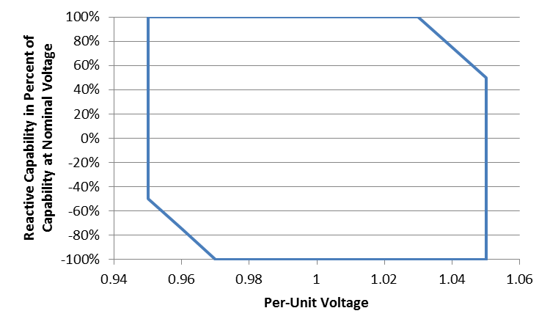

*Figure 2-1 Required reactive capability as function of point of interconnection bus voltage. Positive percentage indicates overexcited (lagging) reactive power, negative percentage indicates under-excited (leading) reactive power.*

## Reactive Power Capability during Undervoltage Conditions

1. The Resource shall have the capability to deliver reactive current to the LIPA transmission system (lagging, or overexcited operation) at the point of interconnection that is at least 33% of the Resource’s output current rating at nominal voltage when the positive-sequence voltage at the point of interconnection is less than 0.95 p.u., and greater than 0.5 p.u., of the nominal voltage.
2. Injection of reactive current at point of interconnection voltage less than or equal to 0.5 p.u. of the nominal voltage is not required.
3. Real current injection may be curtailed to meet the reactive current injection requirements during undervoltage conditions that are specified in this sub-clause.

## Reactive Power Control Capability

The Resource shall have the control capability to regulate its reactive power in any of the following modes: constant reactive power, constant power factor, bus voltage regulation with droop. These control modes shall achieve specified performance at the Point of Interconnection, regardless of whether the Resource is composed of a single generation unit, or a multiplicity of individual generation units.

### Constant Reactive Power Mode

1. In the constant reactive power mode, the net reactive power at the Point of Interconnection shall be automatically maintained at a specified value or setpoint. The minimum range of adjustability for this setpoint shall at least cover the full range of required reactive power capability as specified in Sub-Clause 2.1 of this Annex.
2. The steady-state reactive power flow into or out of the LIPA system at the Point of Interconnection shall be maintained at the more constraining of the reactive power regulation setpoint and the reactive power capability of the Resource as specified in Sub-Clause 2.1 of this Annex, within tolerances of +/- 2% of the Resource’s real power rating.
3. Transient changes of voltage, for which the initial and final phase voltage magnitudes are within the normal range of operation (0.95 p.u. to 1.05 p.u. of nominal), and any changes of the Resource’s real power generation, shall not cause the net reactive power at the Point of Interconnection to vary outside of the specified steady-state reactive power tolerances for a duration in excess of 0.5 seconds.

### Constant Power Factor Mode

1. In the constant power factor mode, the net reactive power at the Point of Interconnection shall be automatically varied in proportion to the real power output, such that a constant power factor is maintained at a specified setpoint. The minimum range of adjustability for this setpoint shall be from 0.95 leading to 0.95 lagging.
2. The steady-state reactive power flow into or out of the LIPA system at the Point of Interconnection shall be maintained at the more constraining of the constant power factor setpoint and the reactive power capability of the Resource as specified in Sub-Clause 2.1 of this Annex, within tolerances of +/- 2% of the Resource’s real power rating.
3. Transient changes of voltage, for which the initial and final phase voltage magnitudes are within the normal range of operation (0.95 p.u. to 1.05 p.u. of nominal), and any changes of the Resource’s real power generation, shall not cause the net power factor to deviate from the specified steady-state tolerances for a duration in excess of 0.5 seconds.

### Voltage Regulation Mode (with Droop)

1. In the voltage regulation mode, the reactive power of the Resource shall be automatically varied to regulate the Point of Interconnection positive sequence voltage magnitude to a specified setpoint, offset by a droop function
2. The minimum range of adjustability for the voltage regulation setpoint shall be from 0.95 to 1.05 p.u. of the nominal voltage
3. The voltage regulation setpoint shall be offset by a droop function that is in proportion to the reactive power output of the Resource.
4. The minimum range of adjustability for the droop function shall be from 0.04 to 0.30 p.u. voltage setpoint offset per per-unit reactive power output. The per-unit base for the reactive power output is the rated real power capacity of the Resource.
5. The Resource shall not be required to provide reactive power greater than as specified in Sub-Clause 2.1 of this Annex in order to regulate voltage. Controls shall be designed to avoid “wind-up” of integral functions when the reactive power output is limited by capacity constraints.
6. The voltage regulation function shall maintain the steady-state point of interconnection positive-sequence voltage magnitude to within ±0.005 p.u. of the specified voltage regulation setpoint, as adjusted by the droop function, to the extent that this voltage regulation performance can be achieved within the reactive capability limits of the Resource.
7. The voltage-regulation function shall have a 0.1 second closed-loop response time under nominal system short-circuit level conditions. Response time is defined as the time from when a step stimulus is initiated (step in voltage regulation setpoint or switching of an external reactive device such as to cause a step change in the voltage) until the Resource reactive output has reached 90% of its final value.
8. For a step change in the voltage regulation setpoint, the resulting voltage response shall not overshoot the final value by more than 10% of the change in steady-state voltages before and following the step.

### Dispatch of Reactive Control Setpoints and Parameters

1. The selection of the reactive control mode and setpoints shall be at the sole discretion of PSEG-LI System Operations.
2. Changes in control mode and setpoints may be changed at any time. The Resource Owner shall be responsible for implementing any ordered changes immediately. In all cases, these changes shall be implemented within ten (10) minutes of issuance of the order by PSEG-LI System Operations.

# voltage and Frequency Disturbance Performance

1. In order to minimize power resource deficiencies in the LIPA system as a result of system voltage and frequency disturbances, which may affect multiple power generation resource facilities simultaneously, ride-through performance requirements are set forth in this clause.
2. The term “remain on line” is used in this clause, and is defined to mean that the Resource retains the ability to maintain real and reactive power output or immediately recover real and reactive power output as specified in this Clause.

## Low-Voltage Ride Through

1. The Resource shall remain on line for the voltage disturbance caused by any single or multi-phase fault on the LIPA transmission grid, having duration equal to the lesser of the normal fault clearing time, plus any subsequent post-fault voltage recovery to the final steady-state post-fault voltage. The initial conditions prior to such fault may include outage of any one LIPA transmission element, inclusive of both circuits of a double-circuit line sharing common transmission tower structures.
2. The Resource shall remain online for any voltage disturbance caused by a single-phase fault on the transmission grid with delayed clearing, plus any subsequent post-fault voltage recovery to the final steady-state post-fault voltage. Clearing time shall be based on the maximum backup clearing time associated with a single point of failure (protection or breaker failure) for any single-phase fault location inclusive of single-phase faults occurring simultaneously on different phases of multi-circuit transmission lines. The initial conditions prior to such fault may include outage of any one LIPA transmission element, inclusive of both circuits of a double-circuit line sharing common transmission tower structures.
3. The Resource shall recover to 90% of its pre-fault current output within 150 ms of the recovery of the point of interconnection positive sequence voltage to 0.85 per-unit of the nominal voltage.
4. The Resource shall recover to the lesser of its pre-fault real power output or the available primary power, within 250 ms of the recovery of the point-of-interconnection positive sequence voltage to 0.95 per-unit of the nominal voltage, subject to the availability of the primary energy source.
5. The Resource shall remain online and maintain stable operation in the post-fault state for the degraded short-circuit level conditions resulting from any fault condition described in (a) and (b), excluding fault conditions for which the clearing requires complete isolation of the Resource from the LIPA transmission system.
6. The Resource shall not be required to remain online for system low-voltage disturbances creating a positive-sequence voltage component less than specified in Figure 3-1 for the cumulative durations shown, nor shall it be required to remain online for unbalanced system voltage disturbances creating a negative-sequence voltage greater than specified in Figure 3‑2 for the cumulative durations shown.

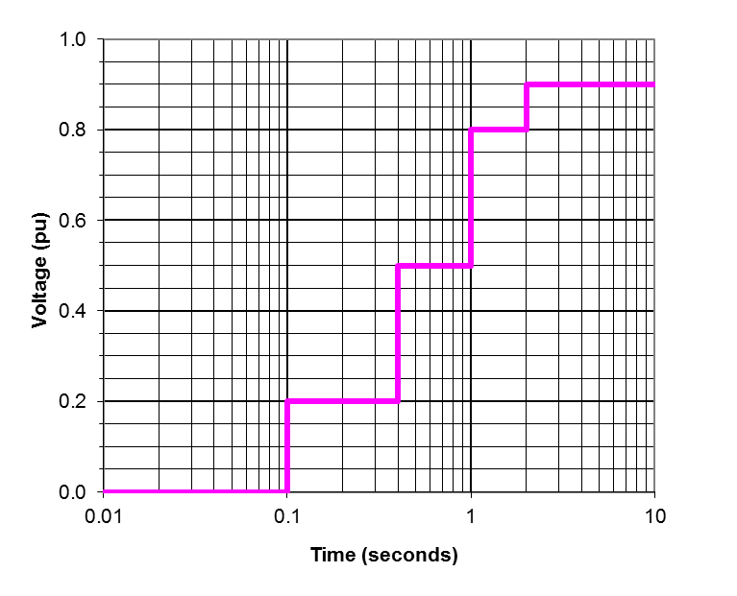

*Figure 3-1 Minimum positive-sequence voltage ride through requirement.*

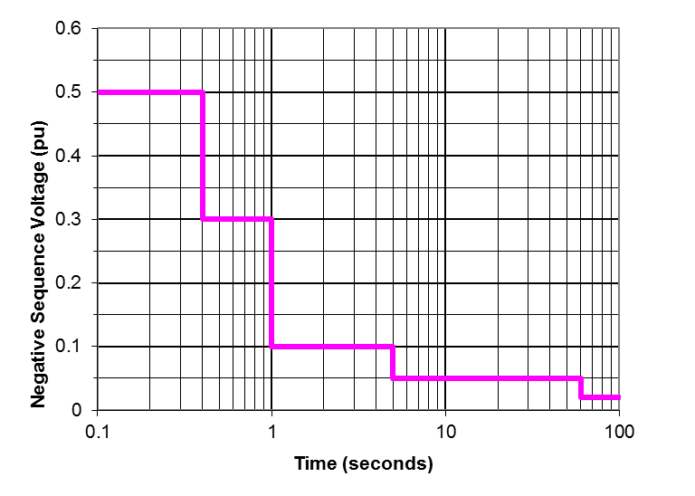

*Figure 3-2 Maximum negative-sequence voltage ride through requirement.*

## High-Voltage Ride Through

The Resource shall remain on line for temporary overvoltages where the maximum phase-to-ground or phase-to-phase per-unit voltage, on any phase, is no greater than the magnitudes and durations specified in Figure 3-3, and which do not result in a negative-sequence component of voltage greater in magnitude and duration than specified in Figure 3-2.

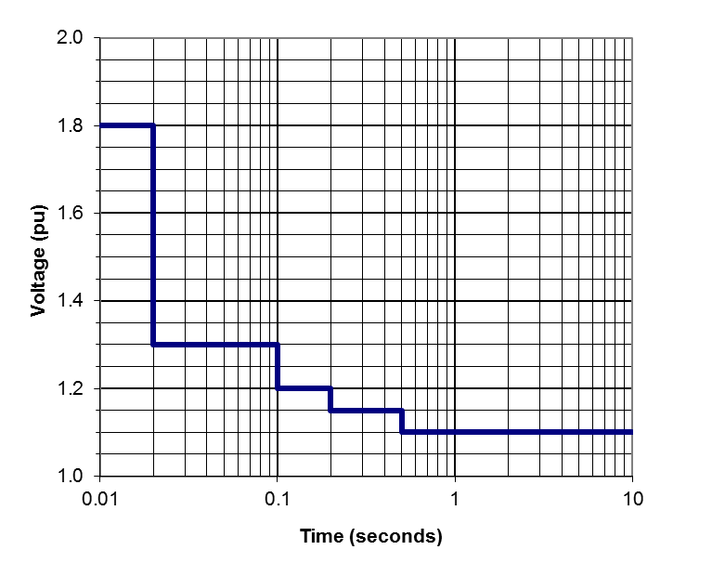

*Figure 3-2 Maximum high voltage ride through requirement.*

## Voltage Disturbances within the Normal Magnitude Range

1. Resources shall remain online for all deviations in voltage magnitude or relative phase angle that do not cause any phase voltage to be outside of the normal voltage range of 0.95 p.u. to 1.05 p.u. of nominal, and which do not cause a negative sequence component of voltage exceeding the magnitudes and durations specified in Figure 3-2.
2. For all voltage disturbances within the normal magnitude range, as specified in (a), the real power output of the Resource shall not deviate more than 10% from the pre-disturbance real power level for greater than 100 ms, and shall not deviate more than 2% from the pre-disturbance real power level for greater than 500 ms, as a direct result of the voltage disturbance. This requirement does not limit power variations due to availability of the primary energy source (e.g., a change in solar irradiance) that is not related to the voltage disturbance.

## Frequency Response and Ride Through

1. The Resource shall remain online for all deviations in frequency less severe in magnitude and duration as specified in Figure 3-3.
2. For over-frequency events exceeding 60.036 Hz, the real power output of the Resource shall be the lesser of the available real power and a power output limit that decreases at the rate of 0.33 p.u. of the pre-disturbance power level per Hz of frequency deviation above 60.036 Hz.
3. For under-frequency events wherein the frequency is less than 59.964 Hz, the real power of the Resource shall be the lesser of the available real power and a power output limit that increases at the rate of 0.33 p.u. of the pre-disturbance power level per Hz of frequency deviation below 59.964 Hz. Limitations to the under-frequency response due to available real power (e.g., level of solar insolation) and equipment physical limitations shall not be deemed as non-compliance with this requirement.

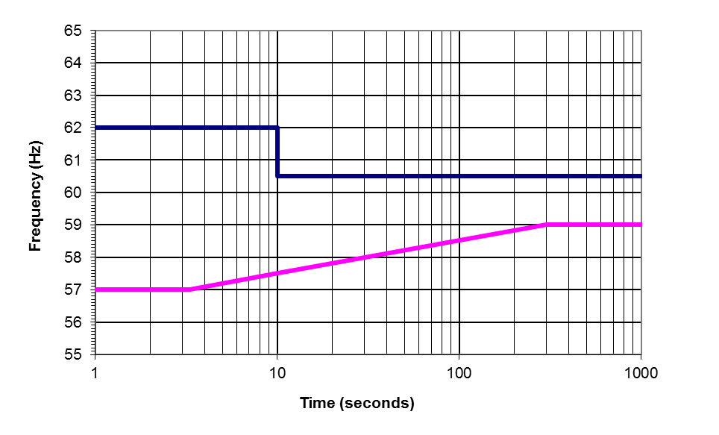

*Figure 3-3 Frequency ride-through range.*

# Harmonic and interference Performance

## Harmonic Current Limits

1. Non-fundamental-frequency current components, at any given frequency, injected into the LIPA transmission system by the Resource shall be less than the values specified in Table 4‑1. The per-unit base is the (rated) current of the Resource when delivering the rated maximum real power at a power factor of 0.95 at nominal voltage. The RSS metric is the square root of the sum of the squares of the individual current frequency components from harmonic orders 2 to 50.

**Table 4-1 – Harmonic Current Limits**

|  |  |  |  |  |  |
| --- | --- | --- | --- | --- | --- |
|  | Harmonic Order | | | | |
| h < 17 | 17 ≤ h < 23 | 23 ≤ h < 35 | 35 ≤ h | RSS |
| Current Limit | 2.0% | 1.5% | 0.6% | 0.3% | 3.0% |

1. For resources having an aggregate power rating at a single point of interconnection to the LIPA transmission system greater than 20 MW, the IT product of the harmonic components shall be less than 10,000 A. The IT product is defined as follows:



Where:

*h* = Harmonic order

*Th* = TIF weighting factor, as documented in IEEE-519, for the frequency of harmonic order *h*

*Ih =* Current injection at harmonic order *h*.

1. The current distortion specifications are applicable to all frequency components above 120 Hz and less than or equal to 3 kHz. Interpolation of the weighting factors shall be used for non-integer harmonics.
2. Harmonic current limitations specified in this sub-clause apply to the currents caused by the Resource, not inclusive of harmonic currents caused by background harmonic voltages existing in the LIPA transmission system exclusive of the Resource.
3. Interharmonics shall be evaluated with respect to the limits applicable to the nearest integer harmonic.

## Harmonic Voltage Limits

1. The Resource shall not cause an incremental increase in voltage distortion at any non-fundamental order from harmonic orders 2 to 50 by greater than 1% of the nominal voltage.
2. The voltage TIF, as defined in IEEE-519, caused by the Resource, shall be less than 25.
3. The voltage distortion specifications are applicable to all frequency components above 120 Hz and less than or equal to 3 kHz. Interpolation of the weighting factors shall be used for non-integer harmonics.
4. These voltage distortion limitations apply to active contribution by the Resource, and exclusive of voltage distortion amplification caused by resonances of passive circuit components.

## Power Line Carrier Interference

1. Power line carrier (PLC) systems are used for protection communications on the LIPA transmission system. The communication channels are in the frequency range of 30 kHz to 500 kHz. Harmonic and electrical noise conducted or radiated from the Resource system shall not interfere with any LIPA power line carrier (PLC) system.
2. In addition to potential interference due to noise injected in the PLC channel frequency range, experience with prior power electronic systems shows the possibility of PLC receiver input overload due to energy in the 4 kHz to 10 kHz frequency range due to PLC receiver input stage overload due to energy outside of the carrier frequency range. The contribution of harmonics and electrical noise injected into the LIPA system by the Resource shall not result in voltage across the drain coils of any LIPA PLC coupling capacitors greater than 5% of their design maximum.

## Radio Frequency Interference

1. The Resource owner is responsible for any radio frequency interference radiated from the Resource installation or the connection line between the Resource facility and the LIPA point of interconnection.
2. The Resource shall not cause radio frequency noise to be radiated from any LIPA transmission line or substation that is of greater intensity than 200 uV/m measured at any point greater than 50’ beyond the perimeter of any substation, or 50’ from the centerline of any LIPA transmission line. Measurements of radio interference shall be in accordance with IEEE Standard 430-1986 (R1991), and made by instruments compliant with ANSI Standard C63.2-1996.

# Control Performance

## Stability

The performance of the Resource shall be stable and without poorly damped oscillations in real or reactive power, exclusive of variations caused by changes in the primary power resource (e.g., solar irradiance), for any system condition yielding a short-circuit capacity at the Resource point of interconnection greater than the minimum short-circuit capacity yielded by any N-1-1 outage contingency on the LIPA transmission system.

## Control Interactions

1. The Resource shall not engage in or cause adverse or unstable interactions with other controls, including generator excitation controls, capacitor switching controls, and transformer tap changer controls, or other power electronic systems including existing HVDC systems, other dynamic reactive support devices, or other non-synchronous generation resources.
2. Resource owner shall have primary responsibility to investigate and correct any actual or potential interactions with any other power electronic-based transmission or generation system that is in commissioned service or under construction prior to the date of the commissioning of the proposed Resource.
3. Respondent shall be required to cooperate with LIPA, PSEG-LI, and the party responsible for any new power electronic-based transmission or generation system installed or proposed to be installed after the commissioning of the proposed ESS. This cooperation shall include providing parameters and control characteristics necessary to investigate and correct any potential or actual interactions between the systems.

# transient and Temporary Overvoltages

1. The Resource shall not cause transient or temporary overvoltages at any point on the LIPA system more severe than the overvoltage envelope defined in Figure 6-1. The temporary voltage envelope for a given bus is defined as the plot of voltage versus time, for which the voltage value at any instant of time is the maximum instantaneous p.u. value of any phase-to-ground or phase-to-phase voltage magnitude (absolute value) during the preceding 16.6666 milliseconds. Overvoltage duration is defined as the total cumulative period of time that the TOV envelope is at or above the given magnitude as a result of a single initiating event.
2. The Resource shall present an effectively grounded source to the LIPA transmission system.
3. Isolation of the Resource shall not cause result in recovery voltages across any LIPA circuit breaker establishing the isolation, in excess of that circuit breaker’s transient recovery voltage (TRV) or voltage rating.

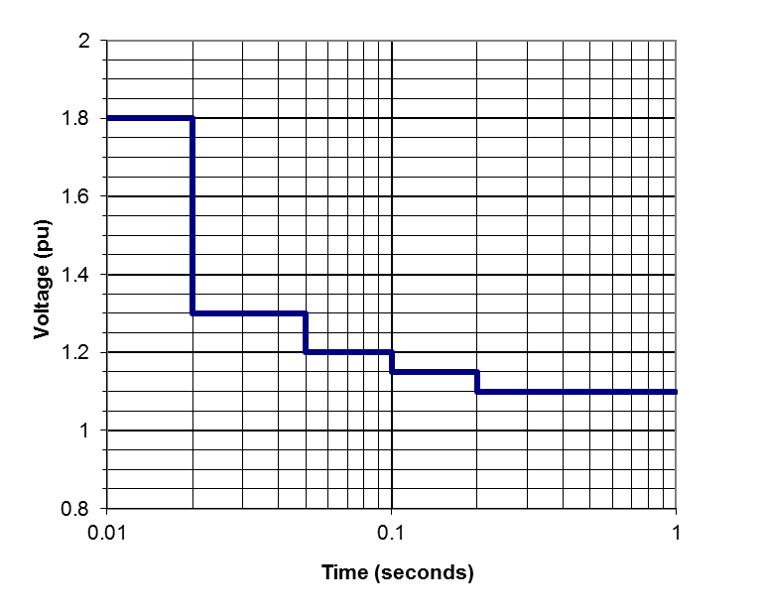

*Figure 6-1 Limits to overvoltage caused by Resource*

# Short-Circuit Contributions

1. Respondents shall fully describe the current contributions of the proposed Resource to near and remote faults. The short-circuit current contribution characterization shall include:
   1. Three-phase, single-phase, phase-to-phase, and double-phase to ground fault types.
   2. Characterization of fault current contributions in phase as well as sequence component formats.
   3. Indication of the phase angle of the current contribution relative to the residual voltage value at the Resource terminals during the fault.
   4. Description of non-fundamental-frequency current components.
   5. Dynamic variations in the ac components of current contribution as well as decay of the dc component, if any.
2. PSEG-LI shall assess whether the short-circuit contribution of any Resource is responsible for total fault currents in excess of the rating of any LIPA system circuit breaker or other component. The costs of upgrading any such equipment subject to excessive duty due to the Resource will be included in the evaluation of Resource proposals.

# Required Dynamic Models

## Positive-Sequence Fundamental-Frequency Model

1. PSEG-LI shall be provided a model, implemented in the Siemens PTI PSS/E dynamic simulation software, Version 32.1.1, that accurately represents the control characteristics and dynamic behavior of the Resource in response to balanced voltage and frequency disturbances, to the extent that such can be validly represented in this type of simulation platform (up to 5 Hz bandwidth in the synchronous reference frame). This model shall be provided prior to the Resource being placed into commercial operation.
2. A fully detailed model is required and a general model is not acceptable.
3. The PSS/E model shall be validated for accurate representation of disturbances that are within the model’s appropriate range of application, using a validated electromagnetic transient model or full-scale testing.
4. The PSS/E model shall be fully documented.
5. The PSS/E model must be non-proprietary and shall be accessible to other utilities, system operators, asset owners, and other entities associated with the interconnected transmission network.
6. The PSS/E model shall be updated by the Resource owner prior to any change to the Resource controls or control parameters that materially affects the dynamic performance.
7. The Resource owner shall ensure compatibility of the provided PSS/E model with the version of PSS/E used by PSEG-LI, as well as compatibility of the latest PSS/E version released by Siemens PTI. Upgrades and modification of the models to maintain compatibility with these PSS/E versions shall be the responsibility of the Resource owner.

## Electromagnetic Transient Model

1. For a Resource, or an aggregation of Resource units at a single point of interconnection, having a maximum real power capacity of 50 MW or greater, PSEG-LI shall be provided an electromagnetic transients model, implemented in the PSCAD simulation software, Version 4.2 or later, that accurately represents the control characteristics and dynamic behavior of the Resource in response to balanced and unbalanced voltage, phase, and frequency disturbances with up to a 1 kHz bandwidth of simulation validity. This model shall be provided to PSEG-LI prior to the Resource being placed into commercial operation.
2. The PSCAD model shall use the same power converter control software algorithms as used in the actual equipment, or a fully validated approximation of these controls that provides modeling fidelity across the specified simulation validity bandwidth.
3. An averaged power converter model may be substituted for a full switching model, provided the averaged model provides valid representation over the specified bandwidth and represents the interactions across the converter, between the ac and dc sides.
4. Documentation shall be provided establishing the validity of the model, such as comparisons between model results and full-scale test results for a sufficient range of tests.
5. The PSCAD model may be proprietary, and be bound by reasonable non-disclosure agreements. The model must be made available to LIPA, PSEG-LI, PSEG-LI’s agents and consultants, and any other party as directed by PSEG-LI, provided that the party is not in direct competition with the Respondent or the Respondent’s Resource equipment manufacturer.
6. The PSCAD model may be provided in a compiled, “black box” form such that the details of the model are not disclosed. Information needed to utilize the model, however, must be adequately documented.
7. Information needed to utilize the model shall be fully documented.
8. The PSCAD model shall be updated by the Respondent prior to any change to the ESS controls or control parameters that materially affects the transient or dynamic performance.
9. The Respondent shall ensure compatibility of the provided PSCAD model with the version of PSCAD specified by PSEG-LI. Upgrades and modification of the models to maintain compatibility with new PSCAD versions shall be the responsibility of the Respondent.

# Appendix B: renewable resource Injection Capability at LIPA Substations

The following Long Island Service Territory Substations cannot accommodate any additional Distributed Generation (DG) into their Distribution Circuits. Some DG input may be possible on the transmission side of the substation:

7DM CENTRAL ISLIP

7M MAC ARTHUR

7T PINELAWN

8DR WILDWOOD

8ED EDWARDS AVENUE

8RX MORICHES

8WF WILLIAM FLOYD

9E BUELL

The following Long Island Service Territory Substations can accommodate up to 4,000 kW of additional Distributed Generation (DG) injection into their Distribution Circuits. Some DG input may also be possible on the transmission side of the substation:

4MG MITCHEL GARDENS

6HL INDIAN HEAD

7EM DEER PARK

7F WEST BRENTWOOD

7S TECH PARK

8HX NORTH BELLPORT

8JR TUTHILL

8T EASTPORT

9A RIVERHEAD

9U MONTAUK

The following Long Island Service Territory Substations can accommodate between 4,000 and 7,000 kW of additional Distributed Generation (DG) injection into their Distribution Circuits. Some DG input may also be possible on the transmission side of the substation:

3R WEST HEMPSTEAD

4H EAST GARDEN CITY

5M NEWBRIDGE

5R BELLMORE

5U MASSAPEQUA

6DL PILGRIM

6L NESCONSET

6U RULAND ROAD

7B BRENTWOOD

7D WEST BABYLON

7J STERLING

7UM SOUTH FARMINGDALE

7XM GREAT RIVER

7Z LINDENHURST

7ZM PINES

8A RONKONKOMA

8B PECONIC

8E CENTEREACH

8EX YAPHANK

8G HOLTSVILLE

8GX WEST YAPHANK

8J SOUTHOLD

8JA JAMESPORT

8M MILLER PLACE

8RR CORAM

8W TERRYVILLE

9AU SUFFOLK AIR

9R BRIDGEHAMPTON

The remaining 103 Substations can accommodate from 7,000 kW to 10,000 kW of additional Distributed Generation (DG) injection into their Distribution Circuits.

1. A “Project” is defined as one size, one location, and one point of interconnection.
2. All MW values are to be considered AC unless specifically noted as otherwise.
3. The Long Island electric system is defined as Zone K excluding the 3 municipal systems of Freeport, Rockville Centre and Greenport.
4. Respondent has the option of submitting the Annual Energy Production Forecasts for each of the 20 years of the contract or to provide a degradation factor that will be applied for each year.